The Stock Exchange of Hong Kong Limited takes no responsibility for the contents of this announcement, makes no representation as to its accuracy or completeness and expressly disclaims any liability whatsoever for any loss howsoever arising from or in reliance upon the whole or any part of the contents of this announcement.

POSSIBLE VERY SUBSTANTIAL ACQUISITION

AND CONNECTED TRANSACTION

POSSIBLE ACQUISITION OF AN INTEREST IN A COMPANY

INVOLVED IN INFORMATION TECHNOLOGY BUSINESS

IN CONNECTION WITH A BROADBAND NATIONAL RAILWAY

FIBRE OPTIC NETWORK IN THE PRC
‍SUMMARY
The Board announced that on 15th August, 2000, the Company entered into the Option Agreement with Founder Group relating to the possible acquisition of up to a 30 per cent. effective interest in CDE for a consideration of up to HK$2,475,000,000 by the exercise of either the Call Option by the Company or the Put Option by Founder Group. Upon exercise of the Option, the issued share capital of Net Age (sole asset of which is its 30 per cent. interest in CDE which in turn holds a 90 per cent. equity interest in the PRC Joint Venture) will be transferred to E-Success (or a nominee of the Company), being a wholly owned subsidiary of the Company, in whole or in tranches in exchange for the issue and allotment of up to 4,500,000,000 New Shares to Founder Group at the Issue Price.
The PRC Joint Venture is involved in information technology business in connection with a broadband national railway fibre optic network in the PRC.
Upon exercise of the Option in full, the New Shares to be issued will amount to 4,500,000,000 Shares, representing approximately 135.3 per cent. of the existing issued share capital of the Company and approximately 57.5 per cent. of the issued share capital of the Company as enlarged by the issue of the New Shares. Based on the total issued Shares of 3,326,773,953 as at the date of this announcement, the aggregate interests of Mr. Lo and his associates in the Company, following the exercise of the Option in full, will increase from about 58 per cent. to about 82 per cent.. Mr. Lo has undertaken that he will ensure to maintain a minimum public float of 25 per cent. for the Shares by way of placement of Shares.
The Transaction constitutes a very substantial acquisition and connected transaction of the Company under the Listing Rules by virtue of the fact that Mr. Lo, being the Chairman and the controlling shareholder of the Company, is the controlling shareholder of Founder Group. Accordingly, the Option Agreement and the transaction comtemplated thereunder are subject to approval by the Independent Shareholders at the SGM.
Trading in the Shares was suspended with effect from 10:00 a.m. on Tuesday, 15th August, 2000 pending the publication of this announcement. Application has been made to the Stock Exchange for resumption of trading in the Shares with effect from 10:00 a.m. on Wednesday, 16th August, 2000.
‍THE OPTION AGREEMENT DATED 15TH AUGUST, 2000
‍Parties
- Founder Group, a company incorporated in the British Virgin Islands with limited liability; and
- the Company
‍Call Option
Under the Option Agreement, Founder Group has granted the Call Option to the Company so that the Company has the right to require, from time to time during the Option Exercise Period, the transfer by Founder Group to E-Success (or a nominee of the Company), being a wholly owned subsidiary of the Company, of all the Net Age Shares, for a consideration of HK$2,475,000,000 to be satisfied by the issue and allotment of 4,500,000,000 New Shares to Founder Group in the ratio of 45,000,000 New Shares for every Net Age Share transferred. The Call Option is exercisable in whole or in tranches. Each exercise of the Call Option by the Company shall be subject to (i) Founder Group being of the reasonable opinion that there has been no material adverse change in the conditions, financial or otherwise, of the Company since the date of the Option Agreement; and (ii) the Company not being in default of any of its material payment obligations to any of its financial creditors. The Company will be obliged to exercise the Call Option in full if it has received proceeds of at least HK$1,500,000,000 from the issuance of new Shares or other securities in the future. As at the date hereof, there is no concrete plan or timetable in respect of any possible issuance of new Shares or other securities of the Company.
‍Put Option
In consideration of the grant of the Call Option, the Company has granted the Put Option to Founder Group so that Founder Group has the right to subscribe, from time to time during the Option Exercise Period, for 4,500,000,000 New Shares at the Issue Price for a consideration of HK$2,475,000,000, to be satisfied by the transfer by Founder Group to E-Success (or a nominee of the Company) in the ratio of one Net Age Share for every 45,000,000 New Shares issued. The Put Option is exercisable in whole or in tranches. Each exercise of the Put Option by Founder Group shall be subject to the Company being of the reasonable opinion that there has been no material adverse change in the conditions, financial or otherwise, of the Project, Net Age, CDE or the PRC Joint Venture since the date of the Option Agreement.
‍Option Exercise Period
Both the Call Option and the Put Option are exercisable at any time within 24 months after fulfillment of the conditions to the first exercise of the Option under the Option Agreement.

‍Assets to be acquired upon exercise of the Option in full
100 shares in Net Age, representing 100 per cent. of the issued share capital of Net Age, the sole asset of which is its 30 per cent. interest in CDE which in turn holds a 90 per cent. equity interest in the PRC Joint Venture.
‍Consideration and payment terms
The consideration of HK$2,475,000,000 for the possible acquisition of a 27 per cent. effective interest in the PRC Joint Venture was arrived at after arm's length negotiations between the Company and Founder Group and represents a discount of approximately 22.3 per cent. to the effective 27 per cent. of the latest valuation by American Appraisal Hongkong Limited, an independent valuer, of approximately RMB12.6 billion (approximately HK$11.8 billion) attributable to the entire equity interest of the PRC Joint Venture as at 31st July, 2000 by adopting the methodology of discounted cash flow.
Upon exercise of the Option in full, all Net Age Shares will be transferred to E-Success (or a nominee of the Company) in exchange for the issue and allotment of 4,500,000,000 New Shares to Founder Group. The issue price of HK$0.55 per New Share was determined with reference to the latest audited consolidated net asset value of approximately HK$0.55 per Share as at 31st December, 1999. The Issue Price represents a premium of approximately 66.67 per cent. over the closing price of the Shares of HK$0.33 on 14th August, 2000, being the last trading day prior to the date of the Option Agreement, and a premium of approximately 90.31 per cent. over the average closing price of the Shares of HK$0.289 for the ten trading days up to and including 14th August, 2000. The Directors are of the view that the Issue Price is fair and reasonable.
Based on 3,326,773,953 Shares in issue as at the date of this announcement, the 4,500,000,000 New Shares represent approximately 135.3 per cent. of the existing issued share capital of the Company and approximately 57.5 per cent. of the issued share capital of the Company as enlarged by the issue of such New Shares. The New Shares, upon issuance, will rank pari passu with the then issued Shares. Application will be made to the Stock Exchange for the listing of and permission to deal in the New Shares.
‍Undertakings
Founder Group has undertaken to procure that during the Option Exercise Period, without the prior written consent of the Company, CDE shall not issue any shares of CDE or securities giving the right to acquire shares of CDE to any person at a price per share of CDE lower than HK$82,500,000 (which is based on the consideration of HK$2,475,000,000 for the acquisition of 30 per cent. interest in CDE) or otherwise effect any changes to the capital structure of CDE.
Another undertaking given by Founder Group under the Option Agreement is that if (i) the Put Option is exercised; (ii) E-Success (or a nominee of the Company) is at any time thereafter directly or indirectly subject to any funding requirement in respect of the PRC Joint Venture, CDE or Net Age and; (iii) in the reasonable opinion of the Company, the Company and its wholly owned subsidiaries as a whole do not have sufficient financial resources to fund such requirement, then Founder Group will procure external finance on terms then obtainable, or failing which, by way of loan from Founder Group to E-Success (or a nominee of the Company), in respect of such funding requirement at an interest rate not exceeding 3 per cent. above the prime rate quoted by The Hongkong and Shanghai Banking Corporation Limited. In the event that the loan advanced by Founder Group to E-Success (or a nominee of the Company), if any, constitutes a connected transaction under the Listing Rules, the Company will comply with the relevant disclosure and/or approval requirements under Chapter 14 of the Listing Rules.
Founder Group has also undertaken to procure the necessary funding in respect of the portion of outstanding capital to be contributed into the PRC Joint Venture by CDE.
Other undertakings given by Founder Group to the Company under the Option Agreement relate to the capital structure and scope of business of the PRC Joint Venture, CDE and Net Age.
‍Warranties
Founder Group gives the Company various representations and warranties relating to, inter alia, its shareholding in Net Age, the shareholding of Net Age in CDE and the equity interest of CDE in the PRC Joint Venture and the title to these shareholdings and equity interest.
‍Conditions to the first exercise of the Option
The first exercise of the Option is subject to, inter alia, the following conditions being fulfilled to the reasonable satisfaction of the Company and Founder Group:--
- the approval of the Option Agreement and the issue of New Shares pursuant to the exercise of the Put Option or the Call Option by the Independent Shareholders, and the approval by the Shareholders of the increase of the authorised share capital of the Company from HK$400,000,000 to HK$2,000,000,000 by the creation of an additional 16,000,000,000 Shares;
- the Listing Committee of the Stock Exchange granting the listing of and permission to deal in the New Shares to be issued pursuant to the exercise of the Put Option or the Call Option;
- the obtaining of all relevant authorisations, consents or approvals of all relevant government and regulatory authorities in relation to the Project and the Option Agreement;
- the receipt by the Company of a legal opinion in relation to the Project in form and substance acceptable to it issued by a firm of lawyers qualified to practise in the PRC; and
- the entry into further agreements as may be reasonably required in connection with the Project.
Such further agreements as stated in condition (v) above include (but not limited to) the master service agreement (details of which are set out in the section headed “Information on Net Age, CDE, the PRC Joint Venture and the Project” below). Apart from conditions stated above, other conditions to the first exercise of the Option include the entry into a shareholders' agreement in relation to CDE and the final form of a shareholders’ agreement in relation to Net Age being agreed.
In the event that any of the conditions set out above is not fulfilled or waived on or before the date which is three months from the date of the Option Agreement (or such other date as may be agreed by the parties to the Option Agreement), the Option Agreement shall be of no further effect.
‍Completion of transfer and subscription of shares upon each exercise of the Option
Subject to the conditions under the Option Agreement being satisfied, completion of the transfer of Net Age Shares and the subscription of New Shares upon each exercise of the Option shall take place within 15 days after the date of the exercise notice given in respect of the Call Option or the Put Option.
‍Option to acquire further interest
Pursuant to the Option Agreement, the Company and Founder Group agree to negotiate, in good faith and on the principles of the Option Agreement, documentation relating to a further option to be granted by Founder Group to the Company for the transfer of up to a further 20 per cent. of the issued share capital of CDE as at the date of the Option Agreement in exchange for the issue and allotment of new Shares. In the event that the grant of such further option by Founder Group to the Company materializes and falls under the provisions of the Listing Rules, further announcement will be made by the Company in such regard.
The Directors are of the opinion and the Company has undertaken that in the event such further option to acquire an additional 20 per cent. issued share capital of CDE is exercised, CDE will not be treated as a subsidiary of the Company and the interest of the Company in CDE will not be consolidated into the accounts of the Company.
‍
Adjustments to number of shares for transfer or subscription
In the event that the Company subdivides or consolidates its ordinary shares or makes a bonus issue or free distribution of shares or assets, then the Issue Price and effectively, the number of New Shares to be issued in consideration of the transfer of the Net Age Shares by Founder Group to E-Success (or a nominee of the Company), shall be appropriately adjusted.
In the event that Net Age subdivides or consolidates its ordinary shares or makes a bonus issue or free distribution of shares or assets, then the number of Net Age Shares to be transferred by Founder Group to E-Success (or a nominee of the Company) in consideration of the issue of New Shares shall be appropriately adjusted.
‍Disclosure of information by Founder Group
Pursuant to the Option Agreement, during the Option Exercise Period, in the event that there is any material change in connection with the Project, Founder Group, Net Age, CDE or the PRC Joint Venture, Founder Group will be obliged to promptly provide any information relating to such change in reasonable details to the Company. Founder Group will also be obliged to provide such further information relating to such change to the Company as the Company may reasonably require. On the basis of such information, the Company will then form a reasonable opinion as to whether there has been any material adverse change in the conditions, financial or otherwise, of the Project, Net Age, CDE or the PRC Joint Venture since the date of the Option Agreement. If Founder Group disputes the reasonableness of the Company's opinion, it may refer the dispute to Ernst & Young, being a firm of chartered accountants, who will act as the expert to make a final and binding determination of such dispute.
‍SHAREHOLDING STRUCTURE
Based on the total issued Shares of 3,326,773,953 as at the date of this announcement, the aggregate interests of Mr. Lo and his associates in the Company, following the exercise of the Option in full, will increase from approximately 58 per cent. to approximately 82 per cent.. Mr. Lo has undertaken that he will ensure to maintain a minimum public float of 25 per cent. for the Shares by way of placement of Shares.
The Stock Exchange has indicated that, in the event that less than 25 per cent. of the Shares are in public hands following any exercise of the Option, it will closely monitor the trading in the Shares. If the Stock Exchange believes that a false market exists or may exist in the Shares, or that there are insufficient Shares in public hands to maintain an orderly market, then it will give consideration to exercising its discretion to suspend dealings in the Shares. The Stock Exchange also has the power to aggregate a series of transactions by the Group and any such transaction may result in the Company being treated as a new listing applicant and/or subject to the requirements for new listing applicants as set out in the Listing Rules.
Prior to any exercise of the Option, the Company holds an attributable interest of approximately 4.92 per cent. in CDE via Founder Group. Upon exercise of the Option in full, the attributable interest of the Company in CDE via Founder Group would be reduced to approximately 3.44 per cent., which, together with its interest of 30 per cent. in CDE acquired by the exercise of the Option, would amount to approximately a total attributable interest of 33.44 per cent.. Ernst & Young, the reporting accountants to the Company, has confirmed to the Company that upon exercise of the Option in full, the interest of the Company in CDE will not be treated as a subsidiary of the Company. Based on the opinion of Ernst & Young, the Company has undertaken that upon exercise of the Option in full, the interest of the Company in CDE will not be treated as a subsidiary of the Company.
Two other shareholders of Founder Group (which together hold an interest of 34 per cent. in Founder Group), namely Glorious Prospect Investments Limited and Top Technologies Limited, and their respective beneficial shareholders are independent of and not connected with the Company, the directors, chief executives or substantial shareholders of the Company, its subsidiaries or their respective associates (as defined in the Listing Rules). Given that the beneficial shareholder of Top Technologies Limited holds 5,429,788 Shares, representing approximately 0.16 per cent. of the issued share capital of the Company as at the date of this announcement, such beneficial shareholder will abstain from voting in respect of the Option Agreement at the SGM.

‍Existing shareholding structure
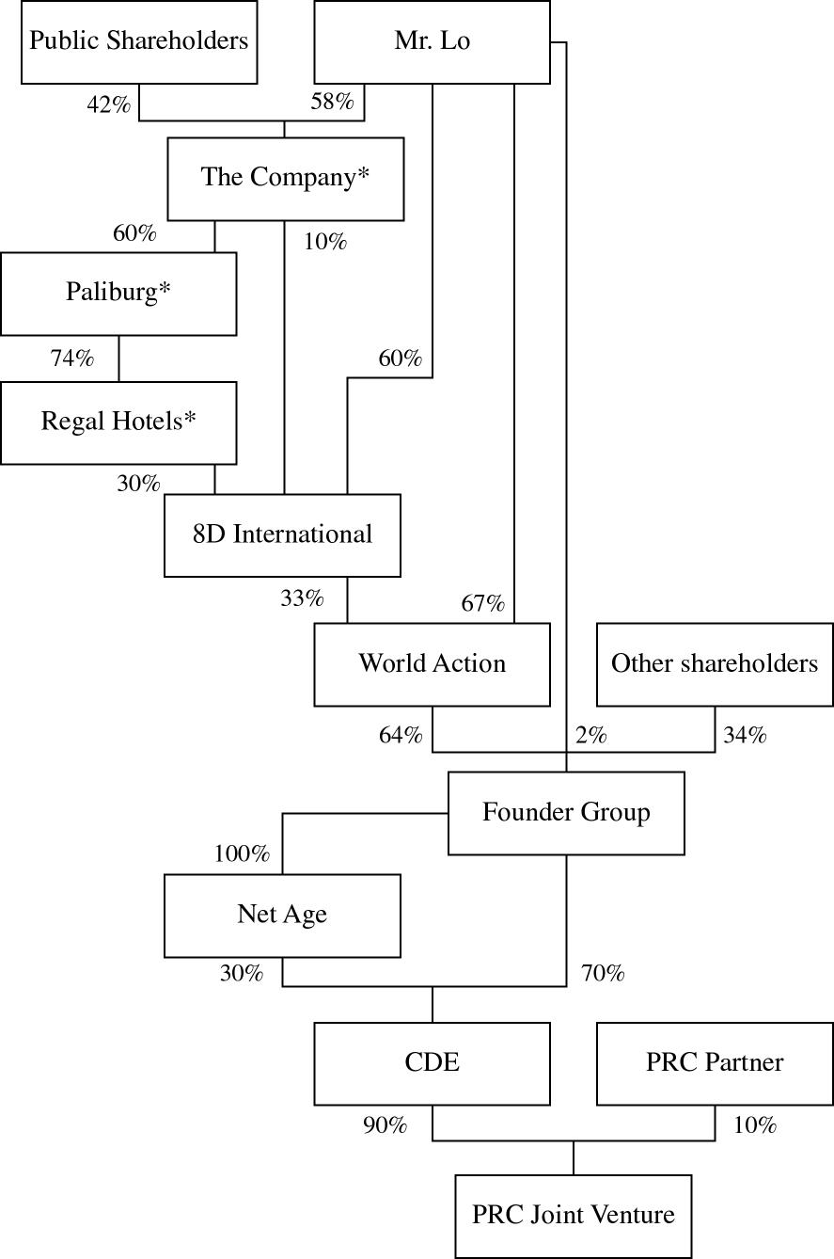
* listed companies in Hong Kong

‍Shareholding structure after full exercise of the Option
(assuming no other changes in the shareholding structure)
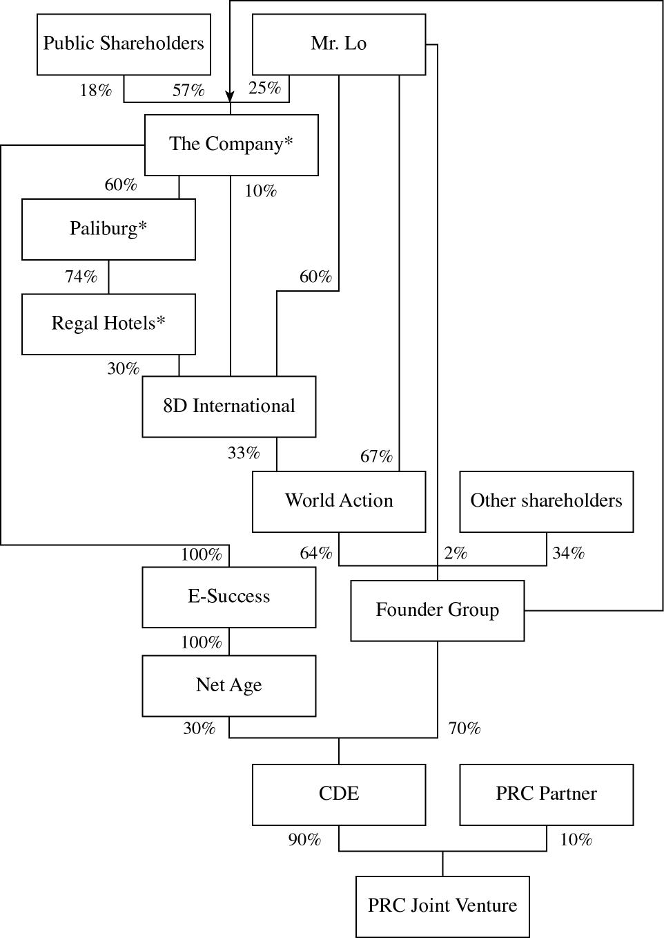
* listed companies in Hong Kong

‍INFORMATION ON NET AGE, CDE, THE PRC JOINT VENTURE AND THE PROJECT
Net Age is an investment holding company incorporated in the British Virgin Islands on 5th July, 2000, the sole asset of which is its 30 per cent. interest in CDE. CDE is an investment holding company incorporated in the British Virgin Islands on 6th January, 2000, the sole asset of which is its 90 per cent. interest in the PRC Joint Venture.
Under the shareholders' agreement in respect of CDE to be executed, Net Age is expected to be entitled to appoint three directors out of 10 directors to the board of CDE. Accordingly, upon exercise of the Option in full, E-Success (or a nominee of the Company) is expected to be entitled to appoint three directors to the board of CDE through Net Age and it is the intention of Founder Group that pursuant to the shareholders' agreement in respect of Founder Group to be executed, among the seven directors entitled to be nominated by Founder Group to the board of CDE, three will be nominated by World Action and Mr. Lo, and four will be nominated by other shareholders of Founder Group. Out of such seven directors of CDE, one of them is an independent director of a jointly controlled entity of the Group. Founder Group has undertaken that, so long as the Company has acquired and holds an interest in CDE by way of exercise of the Option (and not via its existing indirect interest in World Action) and so long as Founder Group has a legal and beneficial interest in CDE, save for one director (who is currently Mr. Lo), any director appointed or to be appointed by Founder Group to the board of CDE will be independent of and not connected with the Company, directors, chief executives or substantial shareholders of the Company, its subsidiaries or their respective associates (as defined in the Listing Rules). Each director of CDE shall be entitled to one vote at board meetings and no second or casting vote arrangement will apply.
The PRC Joint Venture is a sino-foreign equity joint venture company incorporated in the PRC on 24th April, 2000 and presently has a total investment amount and a registered capital both amounting to US$10,000,000 (approximately HK$77.5 million), of which 16.5 per cent. has been paid up and the remaining portion will be paid up within six months from the date of issuance of its business licence on 24th April, 2000. Founder Group has undertaken to procure the necessary funding for the portion of outstanding capital to be contributed into the PRC Joint Venture by CDE. The PRC Joint Venture is currently owned as to 90 per cent. by CDE and as to 10 per cent. by the PRC Partner which is independent of and not connected with the Company, directors, chief executives or substantial shareholders of the Company, its subsidiaries or their respective associates (as defined in the Listing Rules). The term of the PRC Joint Venture is 25 years from the date of issuance of business licence on 24th April, 2000.
Given that Net Age was recently incorporated on 5th July, 2000, it has not recorded any profit or loss. Based on the unaudited balance sheet of Net Age as at 3rd August, 2000, the net assets of Net Age were approximately HK$780.
Based on the unaudited consolidated profit and loss account of CDE for the period from its date of incorporation on 6th January, 2000 to 31st July, 2000, the losses before and after taxation were both approximately HK$5.1 million. Based on the unaudited consolidated balance sheet of CDE as at 31st July, 2000, the consolidated net assets of CDE were approximately HK$11.4 million, which principally comprise bank balance, equipment and deposit for equipment netted off by certain account payables.
Based on the management accounts of the PRC Joint Venture for the period from its date of incorporation to 31st July, 2000, it has recorded a loss of approximately HK$56,000. Based on the unaudited balance sheet of the PRC Joint Venture as at 31st July, 2000, the net assets of the PRC Joint Venture were approximately HK$12.8 million.
The PRC Partner has built up a strategic relationship with an entity of each of the Ministry of Railway, State Forestry Administration and State Administration of Metallurgical Industry and has set up joint ventures with each of these entities to offer industry specific information technology services to entities related to the ministries/bureaus through a fibre optic network as described below. The PRC Joint Venture will enter into a master service agreement with such joint ventures, pursuant to which the PRC Joint Venture will be appointed by such joint ventures as their exclusive technical support provider for a period of 20 years commencing from the date of such master service agreement. Such master service agreement is intended to be executed on or before the date of the SGM and its execution is a condition precedent to the first exercise of the Option. The spectrum of services to be provided by the PRC Joint Venture entails equipment supply and system integration, software design and application, system maintenance and upgrading, and consultancy service on technology aspects and business planning of the Project. Such arrangement serves to secure a group of domestic joint ventures related to the respective ministries/bureaus as core customers of the PRC Joint Venture. A majority of the senior management of the PRC Joint Venture has the relevant qualification and experience in the fields of information technology and engineering. The PRC Partner is expected to form similar strategic relationships with entities related to other ministries and bureaus under the Project. The Directors are of the view that if the PRC Partner succeeds in forming strategic relationships with entities related to other ministries/bureaus, similar exclusive technical support arrangement is expected to be made for the PRC Joint Venture.
It is currently estimated that the total capital expenditure in relation to the Project would be around RMB2.5 billion (approximately HK$2.3 billion). It is expected that such capital expenditure will be financed by way of vendor financing and negotiations with certain renowned global equipment suppliers to provide such vendor financing are underway. In the event that no vendor financing could be arranged and the Option has been exercised in full, the funding to be contributed by E-Success, with reference to its 27 per cent. attributable interest in the PRC Joint Venture, would amount to approximately RMB675 million (approximately HK$631 million). However, pursuant to the Option Agreement, Founder Group undertakes that if (i) the Put Option is exercised; (ii) E-Success (or a nominee of the Company) is at any time thereafter directly or indirectly subject to any funding requirement in respect of the PRC Joint Venture, CDE or Net Age; and (iii) in the reasonable opinion of the Company, the Company and its wholly owned subsidiaries as a whole do not have sufficient financial resources to fund such requirement, then Founder Group will procure external finance on terms then obtainable or, failing which, by way of loan from Founder Group to E-Success (or a nominee of the Company), in respect of such funding requirement. Such undertaking is aimed at ensuring that E-Success (or a nominee of the Company) is able to obtain sufficient financing to fulfil its funding obligations as and when necessary.
The PRC Partner has undertaken to cooperate with those domestic joint ventures as aforedescribed and that the fibre optic network, which is the subject of a master lease agreement entered into between an entity of the Ministry of Railway as lessor and the PRC Partner as lessee, be employed for the services of such domestic joint ventures. Such network is configured along the national railway system of the PRC. The Project is targeted to exploit the ubiquity of this network to provide national coverage allowing access to the targeted users in the PRC. As such, it will allow instant access by the target market without the need to negotiate the right of way to construct the network. In addition, the network junctions of this network in each locality are usually located near the centre of the community such as railroad stations. Thus the network will be strategically and conveniently placed to interconnect with its targeted users.
The Project is expected to deploy a pair of fibre optic strand with a total of 37,500 km in three stages and the construction of such fibre optic network has been substantially completed. It is expected that stage 1 of the network connecting 5 cities with a total length of 2,351 km will be equipped for service by the end of 2000. Stage 2 of the network connecting additional 84 cities with a total length of 17,950 km will be equipped for service in 2001. Stage 3 of the network connecting further 40 cities with a total length of 17,199 km will be equipped for service in 2002. The Project will be fully operational by 2003.
‍REASONS FOR THE TRANSACTION
The Company is an investment holding company and the principal activities of its subsidiaries include property investment and management, property development, development consultancy and project management, construction and construction-related businesses, hotel ownership and management, securities brokering, promotions and communications and other investments.
At present, the Company owns an attributable interest of about 4.92 per cent. of CDE. The Company is one of the founders of CDE and wishes to increase its shareholding in CDE by acquiring interests from other shareholders of CDE. The purpose of the Transaction is to create opportunities for the Company to be further involved in information technology businesses and, more importantly, for revitalising the Company in order to enhance its capability in repaying financial creditors which have an informal standstill arrangement with the Company. The Directors consider that the Transaction is in the interest of the Company and in the absence of which there is no other immediately available proposal in place that can represent a meaningful asset injection which can provide a repayment probability to the financial creditors. Given the anticipation that the Project carries the potential to generate revenue and the huge potential of the high technology network business in the PRC, the Directors are of the view that the Project would constitute a potential source of income to the Group while achieving a diversification of the business portfolio of the Group. The Company has informed the financial creditors of such possible acquisition so as to facilitate the financial restructuring proposal of the Group. The Company will endeavour to raise equity fund from strategic investors as well as from the markets generally through the issue of new Shares.
The terms of the Option Agreement were agreed after arm's length negotiations between the Company and Founder Group. The Directors consider that the Transaction is in the interest of the Company and that the terms of the Option Agreement are fair and reasonable so far as the Company and the Shareholders are concerned.
‍INCREASE IN AUTHORISED SHARE CAPITAL
As at the date hereof, the authorised share capital of the Company is HK$400,000,000, comprising 4,000,000,000 Shares and the issued share capital of the Company is HK$332,677,395.30, comprising 3,326,773,953 Shares in issue. For the purpose of the issuance of the New Shares upon exercise of the Option, the Company proposes to increase the authorised share capital from HK$400,000,000 to HK$2,000,000,000 which is subject to approval by the Shareholders at the SGM.
‍GENERAL
The Transaction constitutes a very substantial acquisition and connected transaction of the Company under the Listing Rules by virtue of the fact that Mr. Lo, being the Chairman and the controlling shareholder of the Company, is the controlling shareholder of Founder Group. Accordingly, the Option Agreement and the transaction comtemplated thereunder are subject to approval by the Independent Shareholders at the SGM.
An independent board committee comprising Messrs. Ng Siu Chan and Anthony Chuang has been appointed by the Board for the purpose of advising the Independent Shareholders in respect of the Transaction. An independent financial adviser will be appointed to advise the independent board committee in such regard.
A circular containing, inter alia, details of the Transaction, the recommendation from the independent board committee, the advice of the independent financial adviser and a notice to convene the SGM, will be despatched to the Shareholders as soon as practicable.
Trading in the Shares was suspended with effect from 10:00 a.m. on Tuesday, 15th August, 2000 pending the publication of this announcement. Application has been made to the Stock Exchange for resumption of trading in the Shares with effect from 10:00 a.m. on Wednesday, 16th August, 2000.
‍TERMS USED IN THIS ANNOUNCEMENT
“8D International” | 8D International (BVI) Limited, a company incorporated in the British Virgin Islands
“Board” | the board of Directors
“Call Option” | an option granted by Founder Group to the Company, under which the Company has the right, upon the fulfillment of certain conditions, to require the transfer of the Net Age Shares by Founder Group to E-Success (or a nominee of the Company) in exchange for the issue and allotment of New Shares pursuant to the terms of the Option Agreement
“CDE” | Century Digital Enterprise Limited, a company incorporated in the British Virgin Islands with limited liability, which is beneficially owned as to about 4.92 per cent. by the Company and has 100 shares in issue as at the date of the Option Agreement
“Company” | Century City International Holdings Limited, a company incorporated in Bermuda, the shares of which are currently listed and dealt in on the Stock Exchange
“Director(s)” | the director(s) of the Company
“E-Success” | E-Success Technology Limited, a company incorporated in the British Virgin Islands with limited liability and a wholly owned subsidiary of the Company
“Founder Group” | Perfect Approach Technology Limited, a company incorporated in the British Virgin Islands with limited liability, which is held by the founding shareholders of the Project
“Group” | the Company and its subsidiaries
“Hong Kong” | the Hong Kong Special Administrative Region of the PRC
“Independent Shareholders” | Shareholders other than Mr. Lo and his associates (as defined under the Listing Rules) and the beneficial shareholder of Top Technologies Limited, being a shareholder of Founder Group
“Issue Price” | the issue price of HK$0.55 per New Share, subject to adjustment
“Listing Rules” | the Rules Governing the Listing of Securities on the Stock Exchange
“Mr. Lo” | Mr. Lo Yuk Sui, the Chairman and the controlling shareholder of the Company
“Net Age” | Net Age Technology Limited, a company incorporated in the British Virgin Islands with limited liability and has 100 shares in issue as at the date of the Option Agreement
“Net Age Shares” | ordinary shares of US$1.00 each in the share capital of Net Age
“New Shares” | Shares which may fall to be issued, allotted and credited as fully paid upon exercise of the Option
“Option(s)” | the Call Option and/or the Put Option
“Option Agreement” | the conditional subscription option agreement dated 15th August, 2000 entered into between the Company and Founder Group in relation to the Transaction
“Option Exercise Period” | within 24 months after fulfillment of the conditions to the first exercise of the Option under the Option Agreement
“Paliburg” | Paliburg Holdings Limited, a company listed on the Stock Exchange and beneficially owned as to approximately 60 per cent. by the Company
“PRC” | the People's Republic of China
“PRC Joint Venture” | 北京世紀中海聯數碼技術有限公司 (Beijing Century Union Digital Technology Limited), a sino-foreign equity joint venture company established on 24th April, 2000 in the PRC
“PRC Partner” | 北京中海聯數碼技術有限公司(Beijing CSU Digital Technologies Limited), a company incorporated in the PRC with limited liability and being the Chinese party holding 10 per cent. equity interest in the PRC Joint Venture, which is independent of and not connected with the Company, directors, chief executives or substantial shareholders of the Company, its subsidiaries or their respective associates (as defined in the Listing Rules)
“Project” | the project involving the provision by the PRC Joint Venture of technical, consultancy and other services for information technology businesses in connection with a broadband national railway fibre optic network in the PRC
“Put Option” | an option granted by the Company to Founder Group, under which Founder Group has the right, upon fulfillment of certain conditions, to subscribe for the New Shares at the Issue Price in exchange for the transfer of its interest in Net Age to E-Success (or a nominee of the Company) pursuant to the terms of the Option Agreement
“Regal Hotels” | Regal Hotels International Holdings Limited, a company listed on the Stock Exchange and beneficially owned as to approximately 74 per cent. by Paliburg
“SGM” | the special general meeting of the Company to be convened for approving inter alia, the Option Agreement and the issue and allotment of the New Shares, by the Independent Shareholders
“Share(s)” | share(s) of HK$0.10 each in the share capital of the Company
“Shareholders” | holders of Shares
“Stock Exchange” | The Stock Exchange of Hong Kong Limited
“Transaction” | the grant of the Option in relation to the possible acquisition by the Company of up to 30 per cent. attributable interest in CDE pursuant to the Option Agreement
“World Action” | World Action Technology Limited, a company incorporated in the British Virgin Islands with limited liability, which is beneficially owned as to approximately 7.7 per cent. by the Company
“HK$” | Hong Kong dollars
“RMB” | Renminbi, the lawful currency of the PRC
“US$” | United States dollars
Note: For the purpose of this announcement, all amounts in Renminbi were translated into Hong Kong dollars at an exchange rate of HK$1.00: RMB1.07 and all amounts in United States dollars at an exchange rate of HK$1.00: US$7.75.
By Order of the Board
Eliza Lam Sau Fun
Secretary
Hong Kong, 15th August, 2000

