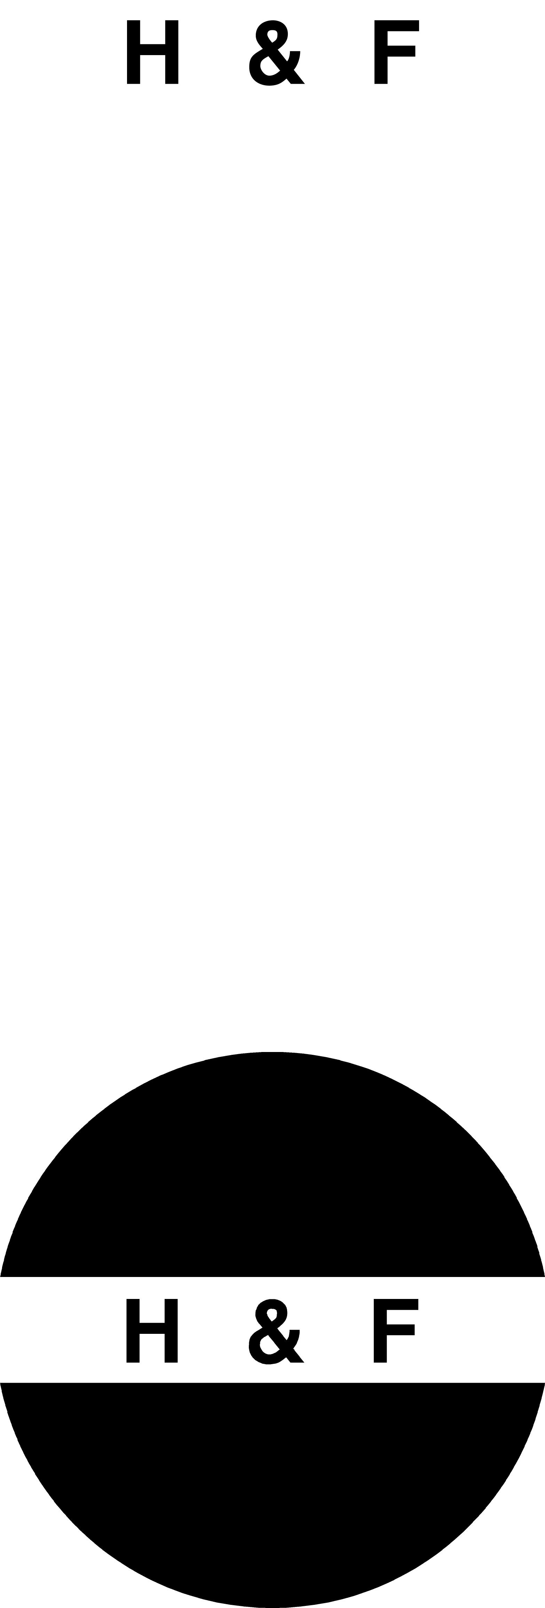
HUNG FUNG GROUP HOLDINGS LIMITED
雄豐集團控股有限公司*
(Incorporated in Bermuda with limited liability)

Announcement of Resignation of Directors
and Appointment of Directors

The Board of Directors (the ``Board'') of Hung Fung Group Holdings Limited (the ``Company'') announces that on 7 December 2000:

1. Mr. Lo Ming Chi was appointed Executive Director of the Company and Mr. Lo was also appointed the new Chairman of the Board of Directors of the Company;

2. Mr. Au Son Yiu and Mr. Goh Gen Cheung have resigned as the Independent Non-Executive Directors of the Company and Mr. Tam Sun Wing has resigned as an Executive Director of the Company;

3. Mr. Wu Wing Kit and Mr. Yuen Chi Choi Simon were appointed Independent Non-Executive Directors of the Company.

The Board would like to take this opportunity to express its appreciation for the valuable contributions of the resigning Directors to the Company and welcome the new directors for joining the Company.

By Order of the Board

Lo Ming Chi

Chairman

Hong Kong SAR, 7 December 2000

* The Chinese name is for identification only

Please also refer to the published version of this announcement in the (Hong Kong iMail)

