The Stock Exchange of Hong Kong Limited takes no responsibility for the contents of this announcement, makes no representation as to its accuracy or completeness and expressly disclaims any liability whatsoever for any loss howsoever arising from or in reliance upon the whole or any part of the contents of this announcement.

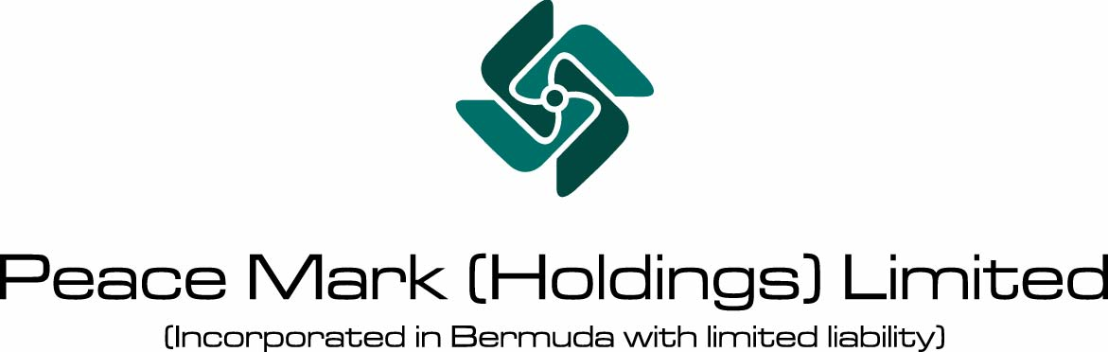

ANNOUNCEMENT
RESULTS OF THE RIGHTS ISSUE OF 367,822,300 RIGHTS SHARES
OF HK$0.10 EACH AT HK$0.18 PER RIGHTS SHARE
ON THE BASIS OF TWO RIGHTS SHARES FOR
EVERY ONE EXISTING SHARE HELD
PAYABLE IN FULL ON ACCEPTANCE

The Directors announced that the Rights Issue closed and became unconditional on Thursday, 22nd August, 2002. 201 valid acceptances have been received for 129,665,467 Rights Shares provisionally allotted under the Rights Issue and 90 valid applications have been received for 26,659,692 excess Rights Shares. Such acceptances include 74,243,832 Rights Shares accepted and paid for by Mr. Patrick Chau and Mr. Leung Yung. The aggregate number of Rights Shares accepted or applied for represents approximately 42.50% of the total number of Rights Shares available under the Rights Issue. Accordingly, the Rights Issue has been undersubscribed.

Each of A-ONE and TIS Securities has taken up the remaining 166,469,400 Rights Shares and 45,027,741 Rights Shares respectively pursuant to the Underwriting Agreement. Upon completion of the Rights Issue, the Company is owned as to 50.35% by A-ONE, Mr. Patrick Chau, Mr. Leung Yung and parties acting in concert with any of them, and 49.65% by public shareholders

Terms used herein shall have the same meanings as defined in the prospectus of the Company dated 5th August, 2002 in respect of the Rights Issue unless the context requires otherwise.

RESULTS OF THE RIGHTS ISSUE

The Directors announced that all the conditions set out in the Underwriting Agreement have been fulfilled and the Underwriting Agreement has not been terminated in accordance with its terms or otherwise. The Rights Issue closed and became unconditional on Thursday, 22nd August, 2002. 201 valid acceptances have been received for 129,665,467 Rights Shares provisionally allotted under the Rights Issue and 90 valid applications have been received for 26,659,692 excess Rights Shares. Such acceptances comprise:

- | 82,081,327 Rights Shares accepted and paid for by applicants (other than Mr. Patrick Chau and Mr. Leung Yung) including 55,421,635 Rights Shares provisionally allotted under the Rights Shares and 26,659,692 excess Rights Shares; and
- | 74,243,832 Rights Shares accepted and paid for by Mr. Patrick Chau and Mr. Leung Yung, which represents approximately 20.18% of the total number of Rights Shares available under the Rights Issue and the respective entitlements of Mr. Patrick Chau and Mr. Leung Yung irrevocably undertaken by each of them to the Company and the Underwriters to take up under the Rights Issue in full. Except for the aforesaid number of Rights Shares accepted and paid for by them, they did not apply for any excess Rights Shares.

The number of Rights Shares accepted or applied for equals to an aggregate of 156,325,159 Rights Shares which represents approximately 42.50% of the total number of Rights Shares available under the Rights Issue. Accordingly, the Rights Issue has been undersubscribed. To perform the obligations under the Underwriting Agreement, each of A-ONE and TIS Securities has taken up the remaining 166,469,400 Rights Shares and 45,027,741 Rights Shares, representing approximately 45.26% and approximately 12.24% of the total number of the Rights Shares available under the Rights Issue respectively. Accordingly, they have no further obligations under the Underwriting Agreement and the Rights Issue became unconditional on 22nd August, 2002.

SHAREHOLDING STRUCTURE OF THE COMPANY PRIOR TO AND IMMEDIATELY AFTER COMPLETION OF THE RIGHTS ISSUE

The shareholding structure of the Company is as follows:

 |  | Immediately before  completion of the  Rights Issue |  |  |  | Immediately after  completion of the  Rights Issue
 |  | Shares | % |  |  | Shares | %
Mr. Patrick Chau |  | 18,730,416 | 10.18 |  |  | 56,191,248 | 10.18
Mr. Leung Yung |  | 18,391,500 | 10.00 |  |  | 55,174,500 | 10.00
A-ONE (Note) |  | - | - |  |  | 166,469,400 | 30.17
Subtotal of A-ONE and its concert parties |  | 37,121,916 | 20.18 |  |  | 277,835,148 | 50.35
TIS Securities |  | - | - |  |  | 45,027,741 | 8.16
Public Shareholders |  | 146,789,234 | 79.82 |  |  | 228,870,561 | 41.49
Total |  | 183,911,150 | 100.00 |  |  | 551,733,450 | 100.00

Note: An investment holding company which is owned as to 50.45% by Mr. Patrick Chau and 49.55% by Mr. Leung Yung.

The 166,469,400 Rights Shares taken up by A-ONE represents approximately 30.17% in the issued share capital of the Company as enlarged by the Rights Issue. As such, the aggregate shareholding interests of A-ONE, Mr. Patrick Chau, Mr. Leung Yung and parties acting in concert with any of them in the issued share capital of the Company as enlarged by the Rights Issue have increased to 50.35%. The fulfillment by A-ONE of its underwriting commitment has caused the aggregate shareholding interests of A-ONE, Mr. Patrick Chau, Mr. Leung Yung and parties acting in concert with any of them in the issued share capital of the Company as enlarged by the Rights Issue to exceed 30%, which has triggered a mandatory general offer under Rule 26 of the Takeovers Code by A-ONE, Mr. Patrick Chau, Mr. Leung Yung and parties acting in concert with any of them, for all Shares other than those already owned or agreed to be acquired by A-ONE, Mr. Patrick Chau, Mr. Leung Yung and parties acting in concert with any of them.

The Whitewash Waiver was granted by the Executive and was approved by Independent Shareholders by poll at the SGM to waive the obligation of A-ONE, Mr. Patrick Chau, Mr. Leung Yung and parties acting in concert with any of them to make a mandatory general offer as a result of A-ONE performing its obligations under the Underwriting Agreement.

GENERAL

It is expected that certificates in respect of the fully-paid Rights Shares will be despatched to those entitled thereto at their own risk by ordinary post to their registered addresses on or before Friday, 23rd August, 2002. Dealing in the fully-paid Rights Shares on the Stock Exchange is expected to commence on Tuesday, 27th August, 2002.

By Order of the Board
Chau Cham Wong, Patrick
Chairman

Hong Kong, 22nd August, 2002

The Directors jointly and severally accept full responsibility for the accuracy of the information contained in this announcement and confirm, having made all reasonable enquiries, that to the best of their knowledge and belief, their opinions expressed in this announcement have been arrived at after due and careful consideration, and that there are no other facts not contained in this announcement the omission of which would make any of their statements in this announcement misleading.

Please also refer to the published version of this announcement in The Standard dated 23 August 2002.

