Pursuant to Chapter 38 of the Listing Rules, the Securities and Futures Commission regulates Hong Kong Exchanges and Clearing Limited in relation to the listing of its shares on The Stock Exchange of Hong Kong Limited. The Securities and Futures Commission takes no responsibility for the contents of this announcement, makes no representation as to its accuracy or completeness and expressly disclaims any liability whatsoever for any loss howsoever arising from or in reliance upon the whole or any part of the contents of this announcement.

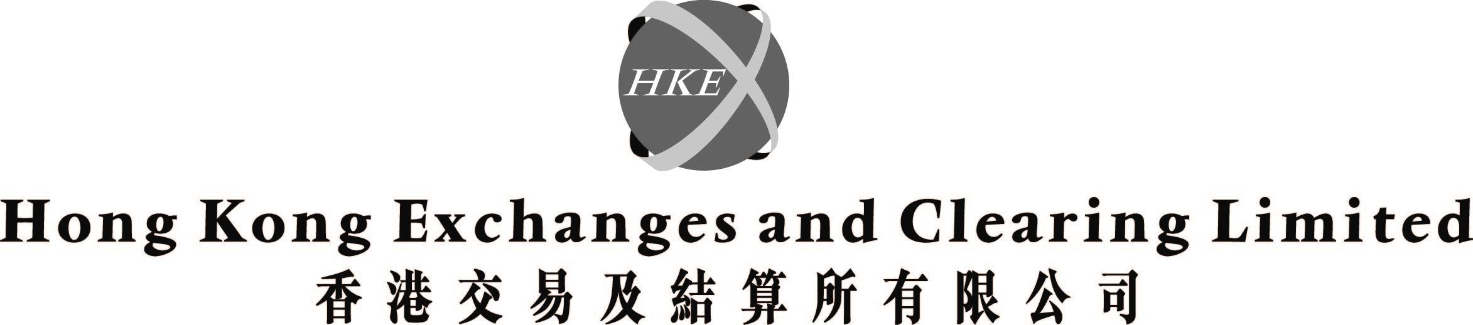
(incorporated in Hong Kong with limited liability under the Companies Ordinance)

Response to recommendations of the Expert Group appointed by the Financial Secretary to review the Operation of the Securities and Futures Market Regulatory Structure

INTRODUCTION

The Expert Group appointed by the Financial Secretary on 26 September 2002 to review the roles and functions of the Government, Securities and Futures Commission ("SFC"), and Hong Kong Exchanges and Clearing Limited ("HKEx") over matters relating to the listing of securities and issuers with listed securities, the operation of the regulatory structure as regards listing matters, published its report on 21 March 2003. The full Expert Group report can be downloaded from
http://www.info.gov.hk/info/expert/expertreport-e.htm.

RECOMMENDATIONS OF THE EXPERT GROUP

The key recommendations of the Expert Group affecting directly HKEx's role over listing matters are as follows -

(i) The listing function must be removed from HKEx and should be performed by a new division of the SFC, to be known as the Hong Kong Listing Authority ("HKLA"), which should process listing applications, and make and administer rules on listing matters. This can be achieved within the legal framework of the Securities and Futures Ordinance. The HKLA should be responsible and accountable for both regulation and market development. It should also be prepared to represent Hong Kong internationally, both to issuers and investors, and to support HKEx in its continued efforts to expand its flow of quality listings, particularly from the Mainland.

(ii) HKEx should be allowed to set its own entry and exit criteria and codes of conduct or rules for listed stocks to trade on The Stock Exchange of Hong Kong Limited ("Stock Exchange"), but these criteria, codes and rules cannot override the rules made by the HKLA. HKEx, relieved of its regulatory burden, should be allowed to operate as a commercial entity with minimal Government influence (for example, with a continuing reduction in the number of Government appointed directors) and less SFC involvement in its day-to-day operations.

(iii) In turn, the SFC should focus its attention on the synergies that integration of the listing function will bring and on ensuring that HKEx is operating fair and orderly securities and futures markets with prudent risk management.

(iv) The HKLA should levy listing fees, both for initial public offerings and maintaining listing status, on a cost-recovery basis. HKEx can charge fees for admission to trading on the Stock Exchange, as a commercial service, at levels that should render the transfer of the listing function bottom line neutral to HKEx. The aim is to preserve Hong Kong's competitive position relative to other markets and therefore the changes should be as close to being cost neutral to the issuers as possible.

GOVERNMENT'S ANNOUNCEMENT

The Government has announced on 21 March 2003 that it accepts the recommendations, and will work with the relevant parties (particularly SFC and HKEx) to draw up a programme for implementing the Expert Group's recommendations for the transfer of listing function. The Government has also stated that it will, in conjunction with both parties, endeavour to ensure that the changes will be bottom line neutral, at the time of transfer, to HKEx as a listed company.

HKEx BOARD'S RESPONSE

In light of the Government's intention to adopt the Expert Group's recommendations, HKEx will work closely with the Government and the SFC on their implementation.

The Board of Directors note the Government's position that the recommended transfer of listing function should be bottom line neutral to HKEx, and would aim to achieve this objective in the discussion with the Government and the SFC on the implementation of the Expert Group's recommendations.

A further announcement may be issued if the Board of Directors considers it appropriate after having a discussion and review of the Expert Group report, and obtained the advice from financial advisors.

This announcement is made by the order of the Board of Directors and the Directors individually and jointly accept the responsibility for the accuracy of this announcement.

Shareholders of HKEx and investing public are advised to exercise caution when dealing in the shares of HKEx.

By order of the Board
Hong Kong Exchanges and Clearing Limited
Joseph Mau
Company Secretary

Hong Kong, 21 March 2003

Please also refer to the published version of this announcement in the South China Morning Post dated 24 March 2003.

