The Stock Exchange of Hong Kong Limited takes no responsibility for the contents of this announcement, makes no representation as to its accuracy or completeness and expressly disclaims any liability whatsoever for any loss howsoever arising from or in reliance upon the whole or any part of the contents of this announcement.
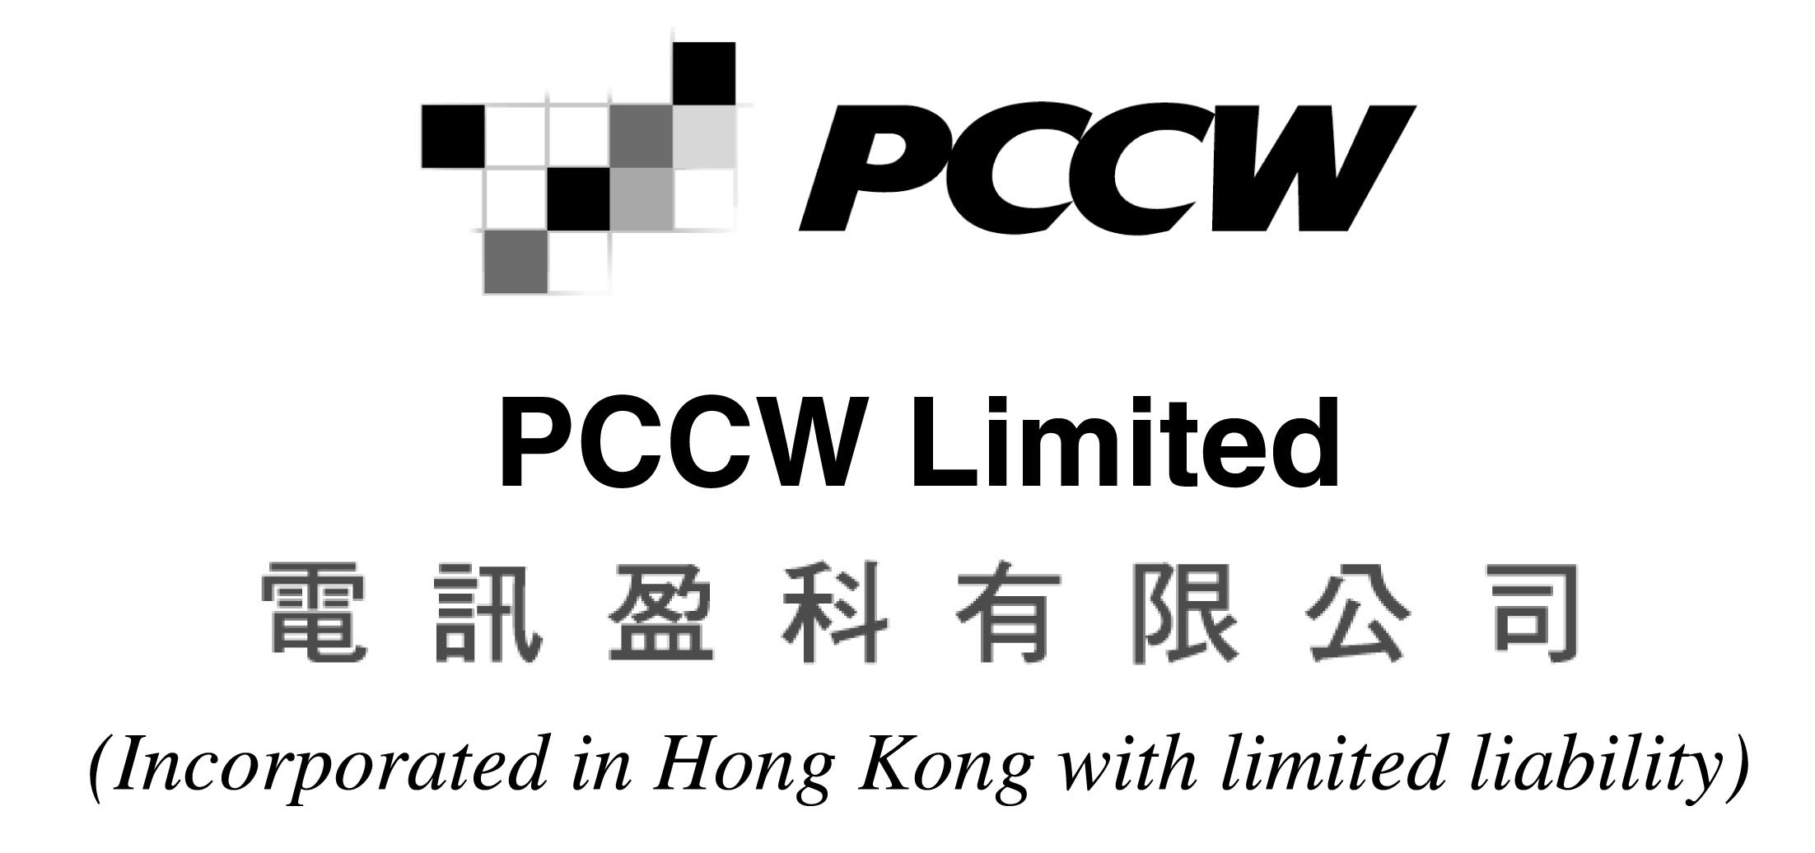
CONNECTED TRANSACTION
PCCW Limited wishes to announce a connected transaction with China Unicom Corporation Limited Guangdong Branch and China Unicom Import & Export Co., Ltd. relating to the provision of certain hardware, database software, system integration and other services.
Such transaction constitutes a connected transaction under Rule 14.25(1) of the Rules Governing the Listing of Securities on The Stock Exchange of Hong Kong Limited as modified by the Modified Calculation Concession (as described in the announcement of PCCW Limited dated September 3, 2003).
Due to an inadvertent oversight, disclosure of the transaction which would have been required by way of press announcement at the time the transaction was entered into was previously overlooked. This oversight constitutes a breach of the Rules Governing the Listing of Securities on The Stock Exchange of Hong Kong Limited and The Stock Exchange of Hong Kong Limited has indicated that it reserves the right to take appropriate action against PCCW Limited and its directors in this respect. Details of the transaction will be published in the next annual report of PCCW Limited.
PCCW Limited (the “Company”) wishes to announce the connected transaction described below involving PCCW (Beijing) Limited (“PCCW Beijing”), an indirect wholly-owned subsidiary of the Company.
CONNECTED TRANSACTION
Each of China Unicom Corporation Limited Guangdong Branch (“CUCL”) and China Unicom Import & Export Co., Ltd. (“UEIL”) are subsidiaries of China United Telecommunications Corporation (“CUTC”). CUCL, UEIL and PCCW Beijing entered into the following agreement on September 22, 2003:
AGREEMENT
Date of Agreement | September 22, 2003
Customers | CUCL and UEIL
Supplier | PCCW Beijing
Services | Provision of hardware, database software, system integration and other related services (together the “Deliverables”) to CUCL and UEIL
Consideration | RMB7,171,298 (approximately HK$6,741,020) negotiated on an arm's length basis with reference to market price, payable by way of cash in three separate installments of approximately 30% on the signing of the agreement, approximately 40% on the installation of the Deliverables, and approximately 30% on the final acceptance of the Deliverables
RELATIONSHIP BETWEEN THE PARTIES
Each of CUCL and UEIL is regarded as a connected person of the Company as (i) China United Telecommunications Corp. (HK) Limited (“CTCHK”), an indirect non-wholly owned subsidiary of CUTC, is a substantial shareholder of ChinaBiG Limited; and (ii) Unicom Xing Ye Science & Technology Company Limited (“Unicom Xing Ye”), an indirect non wholly-owned subsidiary of CUTC, is a substantial shareholder of Unicom Yellow Pages Information Co., Ltd.. ChinaBiG Limited and Unicom Yellow Pages Information Co., Ltd. are both non wholly-owned subsidiaries of the Company. Therefore, each of CUCL and UEIL is regarded as a connected person of the Company as they are associates of each of CTCHK and Unicom Xing Ye. The transaction described above constitutes a connected transaction under Rule 14.25(1) of the Rules Governing the Listing of Securities on The Stock Exchange of Hong Kong Limited (the “Listing Rules”) as modified by the Modified Calculation Concession (as described in the Company's announcement dated September 3, 2003).
Due to an inadvertent oversight, disclosure of the transaction which would have been required by way of press announcement at the time the transaction was entered into was previously overlooked. This oversight constitutes a breach of the Listing Rules and The Stock Exchange of Hong Kong Limited has indicated that it reserves the right to take appropriate action against the Company and its directors in this respect. Details of the transaction will be published in the next annual report of the Company.
REASONS FOR ENTERING INTO THE TRANSACTION
The Company is one of Asia's leading integrated communications companies and provides key services in the areas of: integrated telecommunications; broadband solutions; connectivity; narrowband and interactive broadband (Internet services); business e-solutions; data centers and related infrastructure.
PCCW Beijing was established primarily to design, research and develop computer software, hardware and e-commerce technology, integrated customer management application technology, voice and data communication technology and multimedia technology, as well as computer system integration and network engineering in the People's Republic of China (“China”). The transaction described above is consistent with this objective. In addition, the transaction will provide a revenue source for PCCW Beijing. It is anticipated that the transaction will also strengthen PCCW Beijing's position as a provider of the relevant services in China.
CUCL operates international and domestic long distance calls, data communications and Internet business, radio paging and other related telecommunications value-added services within China. UEIL's businesses encompass equipment tendering and purchasing.
The directors of the Company (including the independent non-executive directors) believe that it is in the interests of the Company for PCCW Beijing to provide the abovementioned services and it is therefore beneficial for the parties to enter into the agreement described above. The terms of the above transaction (including the consideration) have been negotiated on an arm's length basis and on terms no less favourable than those available to or from independent third parties. The directors of the Company (including the independent non-executive directors) believe that such terms are fair and reasonable so far as the shareholders of the Company are concerned.
By Order of the Board
Hubert Chak
Company Secretary
Hong Kong, December 31, 2003
Please also refer to the published version of this announcement in the South China Morning Post.

