The Stock Exchange of Hong Kong Limited takes no responsibility for the contents of the announcements, makes no representation as to its accuracy or completeness and expressly disclaims any liability whatsoever for any loss howsoever arising from or in reliance upon the whole or any part of the contents of this announcement.

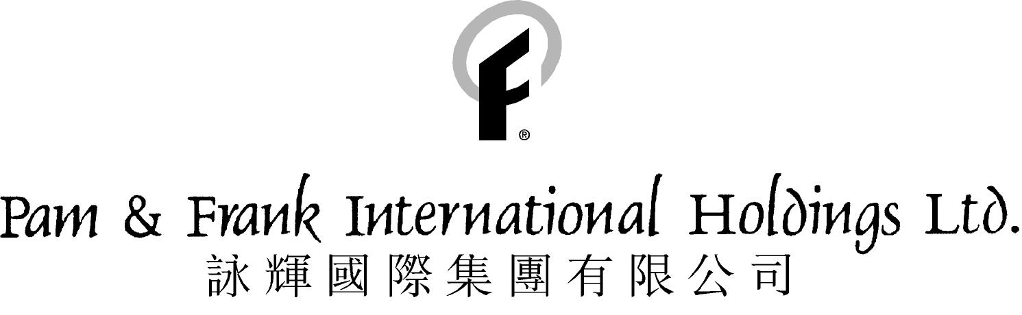
(Incorporated in Bermuda with limited liability)

DELAY IN ANNOUNCEMENT OF AUDITED FINAL RESUTLS

Further postponement of announcement of audited final results for the year ended 30th June, 2000 from on or before 15th December, 2000 to on or before 29th December, 2000 and despatch of 2000 annual report from 8th January, 2001 to 22nd January, 2001. The Company has breached paragraph 8 of the Listing Agreement which requires the final results for the year ended 30th June, 2000 to be released by 30th November, 2000. The Stock Exchange reserves the right to take appropriate action against the Company and/or its Directors regarding the breach.

Mr. Liu Ming Hui, one of the independent non-executive Directors of the Company, sold 300,000 shares of the Company on 21st November 2000. The sale of the Company's shares by Mr. Liu constitutes a breach of paragraph A3 of the Model Code for Securities Transactions by Directors of Listed Companies, pursuant to Appendix 10 of the Listing Rules and the Stock Exchange reserves its right to take all appropriate action against Mr. Liu.

Trading of shares of the Company has been suspended since 23rd November 2000 at the request of the Company pending an announcement in relation to the operations of the Group at the request of the Company. The Company will make an announcement in due course to update the shareholders with relevant information.

Further to the announcement dated 30th Novemebr, 2000 regarding the postponement of announcement of audited final results of Pam & Frank International Holdings Ltd (``the Company'') for the year ended 30the June, 2000, the Company announce that due to difficulties in obtaining complete books and records from the Company's wholly owned subsidiary, Pam & Frank Industrial Company Limited, the unaudited final results for the year ended 30th June, 2000 will also not be available for announcement until on or before 29th December, 2000.

Due to the above reasons, a meeting of the Board of Directors did not take place on 15th December, 2000. It was postponed to 28th December 2000. The Company anticipates that the audited final results for the year ended 30th June, 2000 will be announced on or before 29th December, 2000 and the 2000 annual report will be despatched to shareholders on or before 22nd January, 2001 and the annual general meeting will be held on or before 22nd February, 2001.

This delay will not breach any by-laws of the Company, nor any provisions of Bermuda Companies Act. However, the Company has breached paragraph 8 of the Listing Agreement which requires the audit final results for the year ended 30th June, 2000 to be released by 30th November, 2000. The Stock Exchange reserves the right to take action against the Company and/or its Directors regarding the breach.

The Directors confirmed that, with the exception of Mr. Liu Ming Hui (``Mr. Liu''), one of the independent non-executive Directors of the Company, who sold 300,000 shares on the Company on 21st November,2000, they have not dealt in any shares of the Company since one month immediately preceding 30th November, 2000 and have also given their undertaking to the Stock Exchange that they will not deal in the securities of the Company until the final audited results of the Company for year ended 30th June, 2000 are published. The sale of the Company's shares by Mr. Liu constitutes a breach of paragraph A3 of the Model Code for Securities Transactions by Directors of Listed Companies, pursuant to Appendix 10 of the Listing Rules and the Stock Exchange reserves its right to take all appropriate action against Mr. Liu.

Trading of shares of the Company has been suspended since 23rd November,2000 at the request of the Company pending an announcement in relation to the operations of the Group. The Company will make an announcement in due course to update the shareholders with relevant information.

By Order of the Board

Li Zhong Yuan

Managing Director

Hong Kong, 15th day of December 2000

Please also refer to the published version of this announcement in the (Hong Kong iMail)

