The Stock Exchange of Hong Kong Limited takes no responsibility for the contents of this announcement, makes no representation as to its accuracy or completeness and expressly disclaims any liability whatsoever for any loss howsoever arising from or in reliance upon the whole or any part of the contents of this announcement.

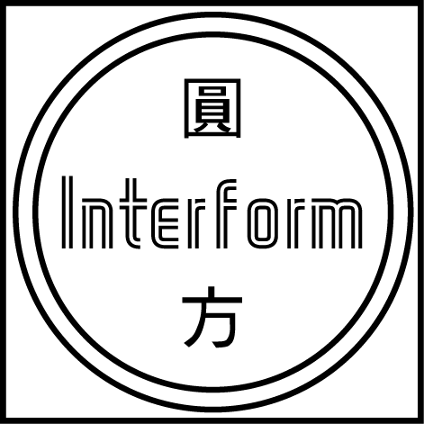
INTERFORM CERAMICS TECHNOLOGIES LIMITED
圓 方 陶 瓷 科 技 有 限 公 司*
(Incorporated in Bermuda with limited liability)

DELAY IN THE PUBLICATION OF THE AUDITED RESULTS OF THE
GROUP FOR THE YEAR ENDED 31 MARCH 2001 AND
DESPACTH OF THE ANNUAL REPORT

The Directors of the Company announce that the publication of the Accounts and the despatch of the annual report of the Company will be postponed to on or before 31 August 2001.

Based on the current progress of the audit and the advice from the Auditors, the Company has applied to the Stock Exchange for an extension of time for the publication of the audited results of the Group for the year ended 31 March 2001 and the despatch of the annual report of the Company to its shareholders on or before 31 August 2001.

The Directors will use its best endeavor to publish unaudited financial results should it be completed and finalized one week before the scheduled board meeting to be held on 21 August 2001 to approve the final audited results.

The Stock Exchange has indicated that the extension of time will not be granted and has reserved its rights to take further action, if any, against the Company for breach of Listing Agreement as a result of the delay.

The board of directors (the "Directors") of Interform Ceramics Technologies Limited (the "Company", together with its subsidiaries, the "Group") announce that there will be a delay in the publication of the audited results of the Group for the year ended 31 March 2001 (the "Accounts"). It is expected that the audited results of the Group for the year ended 31 March 2001 will be published on or before 31 August 2001. The annual report of the Company will be sent to the shareholders on or before 31 August 2001 and the 2001 annual general meeting of the Company will be held on or before 30 September 2001.

The Company has applied to The Stock Exchange of Hong Kong Limited (the "Stock Exchange") for an extension of time for the release of the audited results of the Group for the year ended 31 March 2001 and the despatch of the annual report of the Company for the year ended 31 March 2001 to its shareholders on or before 31 August 2001.

REASONS FOR THE DELAY

The Group was under receivership from 2 September 2000 to 15 May 2001. During receivership and before the completion of Restructuring Agreement (please refer to the joint announcement made by the Company and Tian An China Investments Company Limited dated 15 May 2001), almost all accounting staff had left the Company. The Group's office was moved during receivership in order to reduce rental expenses and the documents were stored in warehouse. Upon the completion of Restructuring Agreement (the "Takeover"), all Directors had resigned and new Directors were appointed. The new Directors were unable to access to the financial information and documentation of the Group before the Takeover. As a result of this, extra time is required for the new management and new accounting staff to review and collect the relevant and necessary information for the preparation of the Accounts. Deloitte Touche Tohmatsu, the auditors (the "Auditors") of the Group began their audit work around the end of June 2001 and have indicated that more time will be required to conduct review of the Group's financial statements and documentation.

The Directors will use its best endeavor to publish unaudited financial results should it be completed and finalized one week before the scheduled board meeting to be held on 21 August 2001 to approve the final audited results.

The Company acknowledges that the delay in the publication of the audited results of the Group for the year ended 31 March 2001 and the delay in the despatch of the annual report of the Company to its shareholders constituted a breach of the paragraphs 8(1) and 11(1) of the Listing Agreement which requires the Group's audited results for the year ended 31 March 2001 to be released by 31 July 2001. The Stock Exchange has indicated that the extension of time will not be granted and has reserved its rights to take further action, if any, against the Company for such breach.

GENERAL

The Directors have not dealt in any shares of the Company within one-month period prior to the date of this announcement and have undertaked the Stock Exchange that they will not deal in the shares of the Company until the audited consolidated results of the Group for the year ended 31 March 2001 are published.

By Order of the Board of Directors
Ng Qing Hai
Chief Executive Officer

Hong Kong, 30 July 2001

* for identification only

Please also refer to the published version of this announcement in the i-Mail.

