The Stock Exchange of Hong Kong Limited takes no responsibility for the contents of this announcement, makes no representation as to its accuracy or completeness and expressly disclaims any liability whatsoever for any loss howsoever arising from or in reliance upon the whole or any part of the contents of this announcement.
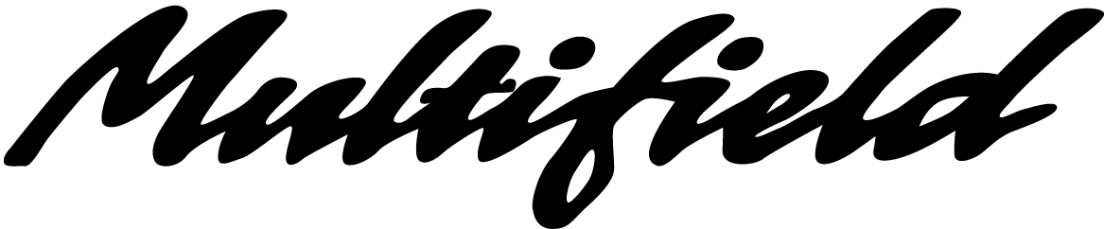

MULTIFIELD INTERNATIONAL HOLDINGS LIMITED
(Incorporated in Bermuda with limited liability)

ANNOUNCEMENT
This announcement is made in respect of the concentration of the Company's public float in the hands of a small number of shareholders as at 31 December 2001.
An announcement on the same subject was made on 20 July 2000.
Shareholders and investors of the Company are therefore reminded to exercise extreme caution when dealing in the shares in the Company.
The Board of Directors of the Company has recently been informed by The Stock Exchange of Hong Kong Limited (the “Stock Exchange”) that on the basis of the information provided by the Securities and Futures Commission to the Stock Exchange, as at 31 December 2001:
-- the shareholding held by the Company's controlling shareholder and chairman, Mr. Lau Chi Yung, Kenneth, and other senior management of the Company, together accounted for 58.69% of the Company’s issued share capital; and
-- 40.03% of the Company's issued share capital was held by 11 other investors (the “11 Shareholders”).
In aggregate, they collectively accounted for 98.72% of the Company’s issued share capital, leaving only 1.28% or 42.89 million shares of the issued share capital in the hands of other public shareholders.
Confirmations have been obtained from the connected persons of the Company and their associates and the Company is not aware of any major changes to the above shareholding structure since 31 December 2001.
Given the concentration of the Company's public float in the hands of a small number of shareholders as at 31 December 2001, the Company hereby makes this announcement on the aforesaid matter to keep the market promptly informed thereof. However, the Company is satisfied that at least 25% of the Company’s issued share capital is in the public hands as required under Rule 8.08 of the Listing Rules of the Stock Exchange.
Furthermore, the Company wishes to advise that an announcement on the same subject was also made by the Company on 20 July 2000 (the “2000 Announcement”). It was stated in the 2000 Announcement that:
-- 6 shareholders collectively held 97.23% of the Company’s issued share capital; and
-- there were only 11.08 million shares or 2.77% of the Company’s issued share capital left in the hands of other public shareholders.
Shareholders and investors of the Company are therefore reminded to exercise extreme caution when dealing in the shares in the Company.
By Order of the Board
Tsang Pak Chung, Eddy
Vice-Chairman
Hong Kong, 1 March 2002
Please also refer to the published version of this announcement in the Hong Kong iMail.

