The Stock Exchange of Hong Kong Limited takes no responsibility for the contents of this announcement, makes no representation as to its accuracy or completeness and expressly disclaims any liability whatsoever for any loss howsoever arising from or in reliance upon the whole or any part of the contents of this announcement.

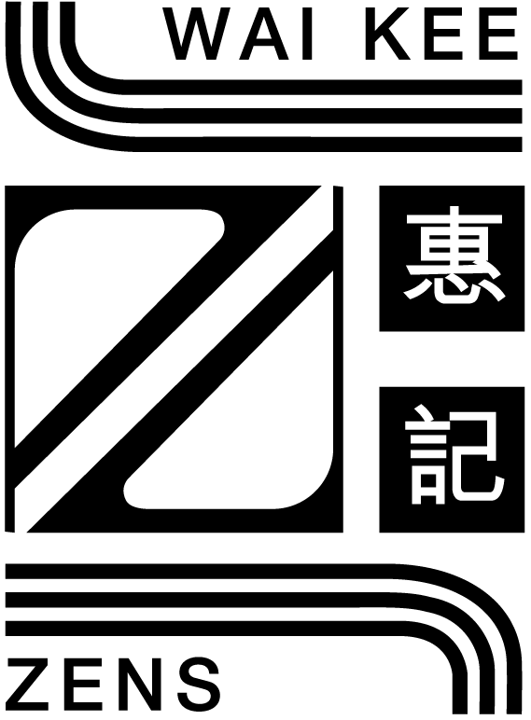

WAI KEE HOLDINGS LIMITED
(Incorporated in Bermuda with limited liability)

ANNOUNCEMENT
The five employees of the Company arrested and subsequently released on bail by the Independent Commission Against Corruption (“ICAC”) have been notified of their unconditional release from bail and no charges will be laid against any of them.
On 22nd March, 2001, the Company announced, amongst other things, that as mentioned in the press on 22nd March, 2001, the Chairman, Vice Chairman, a serving executive director, two members of staff and one former employee of the Company had been arrested and subsequently released on bail by the ICAC.
The Company is pleased to announce that, on 14th March, 2002, the Company has been informed by legal advisors to all of the five employees that the ICAC had granted them unconditional release from bail and there are no restrictions to the release whatsoever as of such date.
The Company has been advised verbally by the ICAC, through their legal advisors, that no charges will be laid against any of the five employees.
By Order of the Board
Keter Fong Shiu Leung
Company Secretary
Hong Kong, 15th March, 2002
Please also refer to the published version of this announcement in the Hong Kong iMail.

