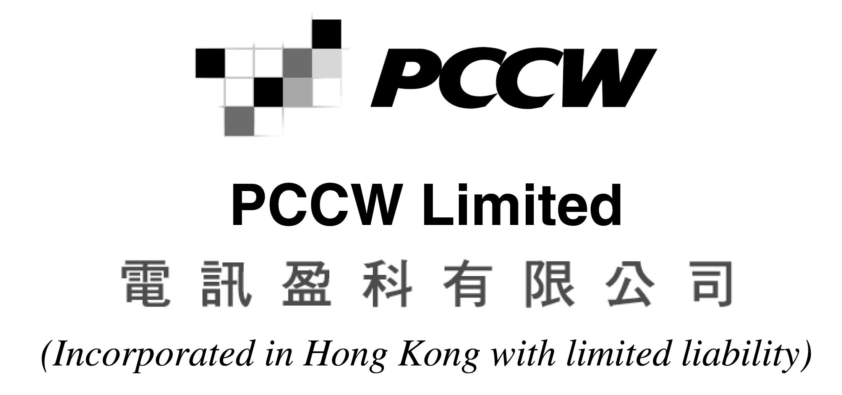
ANNUAL GENERAL MEETING HELD ON MAY 22, 2003
POLL RESULTS
AND RETIREMENT OF DIRECTOR
PCCW Limited (the “Company”) is pleased to announce the poll results in respect of the resolutions proposed and seconded at the Annual General Meeting of the Company held on May 22, 2003 (“2003 AGM”) as follows:
 | Resolutions | Number of Votes (%)
 | Resolutions | For | Against
1. | To receive and consider the audited Financial Statements of the Company and the Reports of the Directors and Auditors for the year ended December 31, 2002 | 1,738,353,351 (99.981%) | 326,238 (0.019%)
1. | As more than 50% of the votes were cast in favour of the resolution, the resolution was duly passed as an ordinary resolution.
2(i). | To re-elect Mr Peter Anthony Allen as a Director | 1,725,138,720 (99.944%) | 966,627 (0.056%)
2(i). | As more than 50% of the votes were cast in favour of the resolution, the resolution was duly passed as an ordinary resolution.
2(ii). | To re-elect Mr Michael John Butcher as a Director | 1,725,106,090 (99.944%) | 969,617 (0.056%)
2(ii). | As more than 50% of the votes were cast in favour of the resolution, the resolution was duly passed as an ordinary resolution.
2(iii). | To re-elect Mr Chung Cho Yee, Mico as a Director | 1,725,098,154 (99.943%) | 981,767 (0.057%)
2(iii). | As more than 50% of the votes were cast in favour of the resolution, the resolution was duly passed as an ordinary resolution.
2(iv). | To re-elect Sir David Ford as a Director | 1,725,122,401 (99.944%) | 962,877 (0.056%)
2(iv). | As more than 50% of the votes were cast in favour of the resolution, the resolution was duly passed as an ordinary resolution.
2(v). | To re-elect Mr Lee Chi Hong, Robert as a Director | 1,725,114,271 (99.943%) | 976,927 (0.057%)
2(v). | As more than 50% of the votes were cast in favour of the resolution, the resolution was duly passed as an ordinary resolution.
2(vi). | To re-elect Mr Yuen Tin Fan, Francis as a Director | 1,725,092,274 (99.943%) | 988,238 (0.057%)
2(vi). | As more than 50% of the votes were cast in favour of the resolution, the resolution was duly passed as an ordinary resolution.
2(vii). | To authorise the Directors to fix the remuneration of the Directors | 1,724,495,232 (99.908%) | 1,590,922 (0.092%)
2(vii). | As more than 50% of the votes were cast in favour of the resolution, the resolution was duly passed as an ordinary resolution.
3. | To re-appoint PricewaterhouseCoopers as Auditors and authorise the Directors to fix their remuneration | 1,739,953,599 (99.974%) | 448,000 (0.026%)
3. | As more than 50% of the votes were cast in favour of the resolution, the resolution was duly passed as an ordinary resolution.
4. | To approve a general mandate to the Directors to issue additional shares | 1,726,663,155 (97.166%) | 50,354,058 (2.834%)
4. | As more than 50% of the votes were cast in favour of the resolution, the resolution was duly passed as an ordinary resolution.
5. | To approve a general mandate to the Directors to repurchase the Company's own securities | 1,739,899,992 (99.972%) | 490,243 (0.028%)
5. | As more than 50% of the votes were cast in favour of the resolution, the resolution was duly passed as an ordinary resolution.
6. | To extend the general mandate granted to the Directors pursuant to item 4 | 1,726,854,502 (97.181%) | 50,092,265 (2.819%)
6. | As more than 50% of the votes were cast in favour of the resolution, the resolution was duly passed as an ordinary resolution.
The Company also wishes to announce that Mr John Todd Bonner informed the Company on May 19, 2003 of his intention to retire as an executive director of the Company and accordingly did not offer himself for re-election at the 2003 AGM.
Mr. Bonner retired as an executive director of the Company with effect from the conclusion of the 2003 AGM.
For and on behalf of
PCCW Limited
Fiona Nott
Company Secretary
Hong Kong, May 22, 2003
Please also refer to the published version of this announcement in the South China Morning Post.

