The Stock Exchange of Hong Kong Limited takes no responsibility for the contents of this announcement, makes no representation as to its accuracy or completeness and expressly disclaims any liability whatsoever for any loss howsoever arising from or in reliance upon the whole or any part of the contents of this announcement.

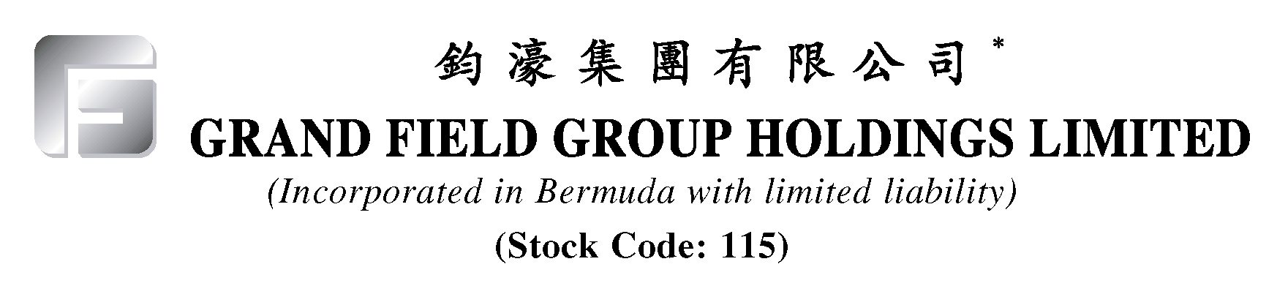

UPDATE ON ANNOUNCEMENT DATED 21ST MARCH, 2007,
RESIGNATION OF DIRECTORS
AND
RESUMPTION OF TRADING

The Board refers to the Company's announcements dated 4th June, 2002, 27th February, 2003, 11th August, 2003 and 21st March, 2007 and wish to update shareholders and investors on the status of certain matters regarding the Company in light of the ICAC investigation.

With a view of restoring credibility to the Board and to distance the Company from the ICAC investigation, Mr. Tsang and Madam Kwok have resigned as executive directors of the Company with effect from 11th July, 2007.

So far as the Company is aware, the ICAC investigation is still ongoing and until charges are either filed against Mr. Tsang and/or Madam Kwok or are formally closed, the Company is uncertain as to the impact of such investigation on the Group. Currently the investigation has not had any material impact on the business of the Group. Shareholders of the Company and/or investors are advised to exercise caution when dealing in the shares of the Company.

At the request of the Company, trading in the shares of the Company on the Stock Exchange was suspended with effect from 9:30 a.m. on 30th January, 2007. An application has been made by the Company to the Stock Exchange for resumption of trading in the Shares with effect from 9:30 a.m. on 11th July, 2007.

The Board refers to the Company's announcements dated 4th June, 2002, 27th February, 2003, 11th August, 2003 and 21st March, 2007. Capitalised terms used herein and not defined shall have the same meaning therein unless the context otherwise requires.

Summary of Independent Auditors' Preliminary Findings

1. The independent auditors have provided written confirmation to the Independent Committee that they have completed their walk-through of the Transaction and have been able to match financials statements for 2002 and 2003 with documentation for the Transaction. Their findings show that there are no irregularities on the accounting entries based on work conducted up to 13th June, 2007.

2. The independent auditors have attended visits at the Company’s subsidiaries in China to understand and review their operations and internal control and to perform related walk-through tests. They had also attended the Company’s Hong Kong office to conduct the same. Based on such work conducted so far, the independent auditors have not found any major deficiencies in the Company’s internal control system nor any compliance shortcomings. The independent auditors have provided written confirmation to the Company confirming that they have found no material weaknesses therein.

3. The independent auditors understand that 315 million shares at nominal value of $0.2 were issued for the satisfaction of the acquisition price of the gas pipeline business in the Transaction for a consideration HK$63 million. Upon disposal of the gas pipeline business, a cash consideration of $32 million was received.

Counsel's Opinion

The Independent Committee had requested Mr. Tsang and Madam Kwok to seek counsel's opinion on the ICAC investigation. Based on the legal opinion of counsel having reviewed all the video recordings of the ICAC investigation of Mr. Tsang and Madam Kwok, the relevant announcements and transaction documents, counsel was of the opinion that there appears to be no conclusive evidence at the moment that could be proof of guilt of Mr. Tsang and Madam Kwok.

Independent Committee's Report

As regards the findings of the Independent Committee, based on contracts reviewed, business plans, previous valuation report conducted at the time of the Transaction, counsel's opinion and announcements made by the Company, no preliminary findings of wrongdoing, irregularities or otherwise have yet been identified. The Independent Committee had identified on some occasions prior to the Transaction a lack of adequate notification for the holding of board meetings but nevertheless consider the Transaction valid regardless. The Independent Committee has also gone through the facts and figures with the independent auditors and have been unable to find any material weaknesses and/or deficiencies on the Group’s internal control.

Resignation of Directors

With a view of restoring credibility to the Board and to distance the Company from the ICAC investigation, Mr. Tsang and Madam Kwok have resigned as executive directors of the Company with effect from 11th July, 2007 and will not undertake any management functions of the Group. The resignation of Mr. Tsang and Madam Kwok is not expected to have any material effect on the business of the Group. Mr. Tsang and Madam Kwok confirmed that they were not aware of any matter that should be brought to the attention of the Shareholders of the Company and that they did not have any disagreement with the Board.

Prior to the resignation of Mr. Tsang and Madam Kwok, they were involved in the seeking of investment opportunities for the Group and overseeing administrative matters of the Group. Following their resignation, their roles will be taken over by Mr. Huang Bing Huang (as to seeking investment opportunities) and Mr. Au Kwok Chuen, Vincent (as to administrative matters). Neither Mr. Huang nor Mr. Au have any family or other business relationship or affiliation with Mr. Tsang and/or Madam Kwok. Mr. Huang has vast experience in property development business as announced by the Company on 6th February, 2007.

Miscellaneous

On 28th April, 2007, a board meeting of the Company was held and in which, inter alia, it was resolved that the ICAC investigation has no material implications (whether financial or otherwise) on the Company and its subsidiaries based on findings/results of counsel's opinion, independent auditors and its own internal review.

The Company will make further announcements on the status of the ICAC investigation as and when applicable.

So far as the Company is aware, the ICAC investigation is still ongoing and until charges are either filed against Mr. Tsang and/or Madam Kwok or are formally closed, the Company is uncertain as to the impact of such investigation on the Group. Currently the investigation has not had any material impact on the business of the Group. Shareholders of the Company and/or investors are advised to exercise caution when dealing in the shares of the Company.

At the request of the Company, trading in the Shares on the Stock Exchange was suspended with effect from 9:30 a.m. on 30th January, 2007. An application has been made by the Company to the Stock Exchange for resumption of trading in the Shares with effect from 9:30 a.m. on 11th July, 2007.
By Order of the Board
Grand Field Group Holdings Limited
Wong King Lam, Joseph
Director
Hong Kong, 10th July, 2007

As at the date of this announcement, the Board of Directors of the Company comprises Mr. Huang Bing Huang, Mr. Wong King Lam, Joseph and Mr. Au Kwok Chuen, Vincent as executive directors and Mr. Hui Pui Wai, Kimber, Mr. Lum Pak Sum and Dr. Wong Yun Kuen as independent non-executive directors.

* For identification purposes only

